
Department of Computing

MANAGEMENT OF I.T. PROJECTS
(55-604612-CF-20256)

Project Initiation Document

South Yorkshire Buses (SYB) Journey Planner
Project Initiation Document Group 2:
- Elekir Moyuwen (c3028707)
- Javani Morris (c3009616)
- Jack Watson (c3026923)
• Samuel Okunowo (c3055721) MANAGEMENT OF I.T. PROJECTS 1
Project Initiation Document 3
Project Overview 4
Objectives 4
Business Objectives 4
Project Objectives 4
Benefits 4
Scope 5
Deliverables 5
Exclusions 5
Constraints 5
Methods and Standards to Be Used 5
Hardware/Software platforms 6
Authorities & Responsibilities 6
Resources 7
Business Case 7
Options Considered 7
Force Field Analysis: 8
Quality plan 8
MoSCoW Analysis 9
Team Meeting Minutes 10
Client Meetings - Feedback 14
Appendices 15
Appendix 1: Low Fidelity Prototype Sketches 15
Register/Login 15
Payment 16
Tickets 17
Settings 18
Map (Plan Journey/View Bus Stops) 19

Project Initiation Document
Version History:
Version | Week Commencing | Amendment  History | Authors
1.0 | 24-SEP-2025 | First draft of PID | All
1.1 | 01-OCT-2025 | After first client meeting | All
1.2 | 08-OCT-2025 | Created Cost benefit appraisal | All
1.3 | 15-OCT-2025 | Created Risk  register, Risk Map,  RAID Log & Force  Field Analysis | All
1.4 | 22-OCT-2025 | Updated Risk  Register, Risk Map,  RAID Log | All
1.5 | 29-OCT-2025 | Updated PID (client questions for second meeting) | All
1.6 | 05-NOV-2025 | Created low-fidelity and high-fidelity prototypes | All
1.7 | 12-NOV-2025 | Created Product  Breakdown  Structure and Work  Breakdown  Structure | All
1.8 | 19-NOV-2025 | Created MoSCoW  Analysis based on  Functional  Requirements  Created GANTT  Chart with MS  Project | All
1.9 | 26-NOV-2025 | Chose PRINCE-2  Agile for the product methodology | All
2.0 | 03-DEC-2025 | Made use of Jira for project delivery | All
2.1 | 10-DEC-2025 | Created Quality  Assurance  Cleaned up  Appendices section  Updated/Cleaned up  Meeting Minutes | All

Project Overview
This Project Initiation Document covers the South Yorkshire Buses (SYB) Journey Planner, a mobile‑first application designed to help passengers plan journeys, check next‑bus times, and get ticket recommendations before boarding. It explains why the project should proceed, how it will be managed, who is involved, and what artefacts will be delivered. These include the business case, planning documents, risk and quality plans, and a high‑fidelity prototype. Together, they provide the evidence and structure needed for future decisions regarding the product.

Objectives

Business Objectives
- Improve customer experience by reducing enquiries about arrivals and delays with clear journey information.
- Increase SYB’s digital engagement and alignment with Stagecoach and First Bus.
- Reduce boarding delays by encouraging more pre‑trip ticket selections through recommendations.
- Ensure accessibility standards are met for diverse users.

Project Objectives
- Provide a high‑fidelity prototype and complete project management artefacts by mid‑December 2025.
- A→B routing, next‑bus times, ticket recommendation UI, live‑status banner should be met in the prototype.
- Colour scheme should be consistent with Stagecoach and First Bus.
- Keep to MVP (Minimum Viable Product) and document a roadmap for further enhancements to the project.

Benefits
The project is estimated to deliver:
- Faster boarding times and fewer timetable enquiries.
- Improved customer satisfaction and stronger public image for SYB.
- Lower risk for the product’s future builds due to clearer goal and investment appraisal.

Scope

Deliverables
- Project management artefacts: Business Case, COCOMO II, investment appraisal, Force Field Analysis, Gantt chart, RACI matrix, risk register/RAID, use case diagram, quality plan.
- Prototype: Wireframes, high‑fidelity prototype, video walkthrough, branding mockups (logo approved by client).
- Services: Map API provider options (Google, Mapbox, TransportAPI), cloud hosting options, and database.
- Handover materials: Deployment document (concept), runbooks, test report templates, access information, support window, final sign‑off checklist.

Exclusions
- Full in‑app payment integration for launch.
- Deep integration with third‑party loyalty or marketing platforms.
- Full production build; native iOS/Android apps.

Constraints
- Budget: Fixed £65,000 for development.
- Timeline: Mid‑December 2025 target for artefacts and envisioned solution.
- Platforms: Mobile‑first responsive web (iOS and Android browsers).

Methods and Standards to Be Used
PRINCE-2 Agile is the methodology decided upon for this project. It combines PRINCE2’s governance (clear roles and responsibilities, business case, stage boundaries with controls and management products such as PID and RAID log) with Agile’s delivery practices (iterative wireframes and prototype, MoSCoW with W representing “Won’t” instead of “Would”, and incremental feedback from client).
- Incorporation:
- PRINCE2:
- Business case maintained and updated (PID).
- Defined roles and responsibilities.
- Stage boundaries via planning and Gantt chart.
- Risk and quality plans.
- Management products (Work Breakdown Structure, RACI chart, RAID log, investment appraisal).
- Agile:
- Iterative UI development (wireframes, high‑fidelity prototype, video walkthrough).
- Improvements and integrations to artefacts and product through client meeting feedback.
- MoSCoW prioritisation.

Hardware/Software platforms
Mobile application is restricted to iOS and Android

Authorities & Responsibilities
- Project Manager (Jack): Responsible for planning, GANTT chart, Work Breakdown Structure, updating stakeholders and team on changes, and overall delivery.
- Project Sponsor (Javani): Responsible for budget decisions and approval, informed of progress with the product and consulted on Business Case and major artefact.
- Business Analyst (Elekir): Responsible for requirements, use cases, and acceptance criteria, and consulted on Business Case and MoSCoW analysis.
- Designer: Responsible for wireframes, branding integration, high‑fidelity prototype, and video walkthrough.
- Risk Manager: Responsible for risk assessment (RAID log, risk register and risk map).
- Software Team Lead & Engineers: Responsible for technical evaluations and conceptual deliverables (source code, deployment document) and integrations with the API and database.
- Quality Manager (Samuel): Responsible for Quality Plan, accessibility checks, test reports, and handover documents.

Resources
- People: 4 team members.
- Money: £65,000 excluding staff costs.
- Equipment: Shared Git repository; Figma (prototyping).
- Time: Delivery by mid‑December 2025

Business Case

Options Considered
SYB needs a reliable and accessible way for passengers to plan their bus journeys and choose tickets. The artefacts and prototype produced show feasibility, costs, risks and solutions, letting the client make an informed decision on funding a full build of the product.
- Option A: Do nothing - No upfront cost but no improvement in customer experience or accessibility. Boarding delays and enquiries continue as a result.
- Option B: Minimal change - Basic digital timetables; quick and cheap but limited benefit; no live updates or routing.
- Option C: Managed envisioned solution - Recommended option to deliver project management artefacts and a high‑fidelity prototype with a video walkthrough. This demonstrates feasibility and provides decision evidence in preparation for making a full build in the future.

Force Field Analysis:
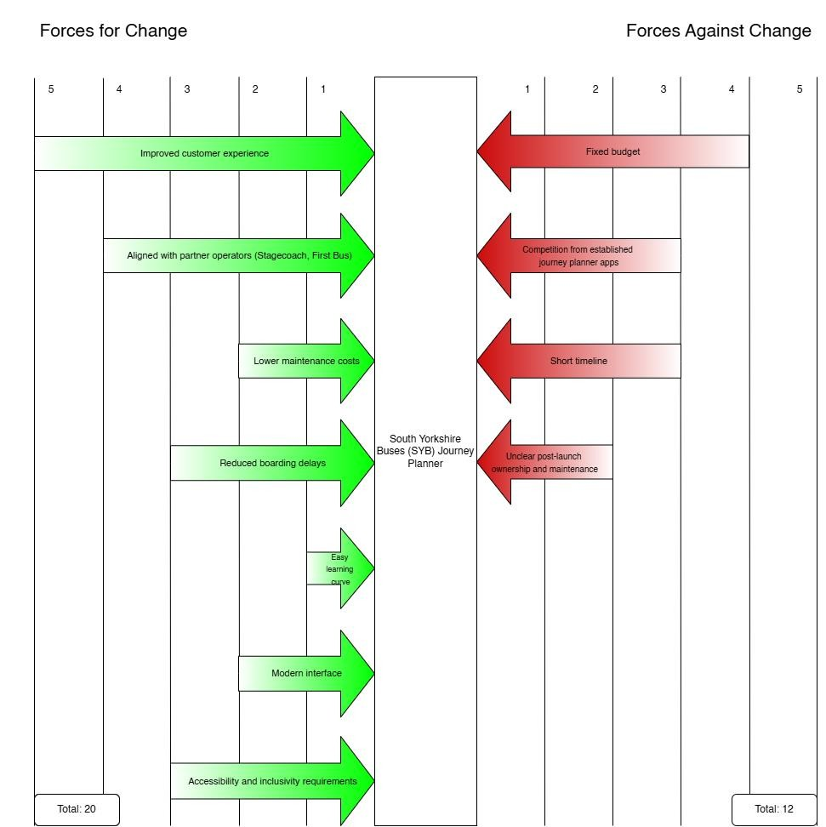
Figure 1 Force Field Analysis Totals: Forces for (19) and Forces against (12)

Quality plan
A Quality Plan has been developed to guarantee that the South Yorkshire Buses (SYB) Journey Planner project produces deliverables that are suitable for the objective, align with stakeholder expectations, and are acceptable for further development beyond the prototype stage. According to the PRINCE2 Agile principles, quality is considered as a controlled process rather than an afterthought, with clear responsibilities, specified quality requirements, and planned quality control procedures.

The Quality Plan specifies the project's quality objectives, standards of quality, and responsibilities for quality assurance and control throughout its lifecycle. It also specifies the testing strategy, which includes system testing and user acceptance testing (UAT) based on prioritised user stories and MoSCoW criteria. This ensures traceability between business needs, functional requirements.
Quality control techniques, including structured reviews, version control, and collaborative technologies, are used to ensure consistency and transparency in project artefacts. Project quality risks are managed by aligning it with the Risk Register, which ensures that qualityrelated risks are consistently monitored and reduced.
The full Quality Plan is provided as a separate document: [ Quality plan Link ]

MoSCoW Analysis
Table 1 MoSCoW Analysis for Functional Requirements
ID | Requirement | Priority (MoSCoW)
FR01 | The system shows journey durations and the estimated arrival times. | Must
FR02 | The system allows the user to show by departure time and by arrival time. | Should
FR03 | The system allows the user to enter their starting location and intended/end destination. | Must
FR04 | The system calculates available bus routes between starting location and end destination. | Must
FR05 | The system makes use of the user’s physical location (after permission is granted by user) | Must
FR06 | The system lists all nearby bus stops (if location is enabled) | Must
FR07 | The system lists all upcoming bus times for any given selected bus stop. | Must
FR08 | The system shows all ticket options for each journey. | Must
FR09 | The system allows uers to zoom and pan on the map. | Should
FR10 | The system allows users to search for stops and/or destinations. | Must
FR11 | The system allows users to filter search results by distance or estimated cost. | Should
FR12 | The system allows users to save favourited bus stops. | Could
FR13 | The system allows users to save favourited bus routes. | Could
FR14 | The system allows administrators to send service update notifications to users. | Won’t
FR15 | The system allows administrators to manually alter bus stops and their timetables. | Won’t

Team Meeting Minutes
Meeting Date | 24th September 2025
Meeting Purpose | Initial Meeting to assign roles
Attendees | - Elekir Moyuwen  - Javani Morris  - Jack Watson  - Samuel Okunowo
Agenda Items
1. Determine project roles
Actions
1. Add our team roles in PID

Meeting Date | 29th October 2025
Meeting Purpose | Determine what to present for feedback
Attendees | - Elekir Moyuwen  - Javani Morris  - Jack Watson  - Samuel Okunowo
Agenda Items
1. Determine what to get feedback on
Actions
- Ask for feedback on Cost Benefit Appraisal
- Create a use-case diagram for later use (if we need to show client)

Meeting Date | 5th November 2025
Meeting Purpose | Determine how to proceed with low fidelity prototype.
Attendees | - Elekir Moyuwen  - Javani Morris  - Jack Watson  - Samuel Okunowo
Agenda Items
1. Allocate sections of the low fidelity prototype amongst us.
Actions
- Each to produce a sketch or sketches of assigned areas for prototype.
- Share sketches with group.

Meeting Date | 12th November 2025
Meeting Purpose | Catch-up, Logo Finilisation
Attendees | - Elekir Moyuwen  - Javani Morris  - Jack Watson  - Samuel Okunowo
Agenda Items
- Identity artefacts which need started/completed.
- Identify artefacts which need updated
- Update the logo used in high-fidelity prototype.
Actions
- Share updated/new artefacts before end of week:
  - Cost Benefit Analysis
  - NFRs and MoSCoW Analysis
  - Project Breakdown Structure
  - Work Breakdown Structure
  - RACI Matrix
- Update logo and add it to relevant screens in the high-fidelity prototype.

Meeting Date | 3rd December 2025
Meeting Purpose | Catch-up and determine Mapping API
Attendees | - Elekir Moyuwen  - Javani Morris  - Jack Watson  - Samuel Okunowo
Agenda Items
- Identify which artefacts need updated.
- Identity which areas of PID need updated.
- Identify a suitable mapping API to satisfy client.
Actions
- Share updated artefacts before end of week:
  - Work Breakdown Structure
  - RACI Matrix
  - Gantt Chart
- Update PID in required sections
- Update Mapping API in Cost Benefit Appraisal and PID

Meeting Date | 10th December 2025
Meeting Purpose | Discuss presentation and feedback from it
Attendees | - Elekir Moyuwen  - Javani Morris  - Jack Watson  - Samuel Okunowo
Agenda Items
1. Act based on feedback provided on our artefacts.
Actions
- Update presentation (mention that it is a mobile application)
- Update Work Breakdown Structure (add numbering)
- Update Force Field Analysis (add totals)
- Update Cost Benefit Appraisal (refer to websites used)
- Update RACI Matrix (number the tasks)
- Update COCOMO estimate (add a graph for Acquisition Phase Distribution)
- Update Risk Register (add colours to Probability and Impact)
- Update Risk Map (create Risk Matrix)
- Update RAID Log (add RPN numbers)
- Update Quality Plan
- Update MoSCoW Analyis (add colours/make colourful)
- Make sure that meeting minutes are added in PID

Client Meetings - Feedback
Meetings | Date | Feedback
1 | 01/10/2025 | - Client wants the colours used within application to which representative of the local bus companies;  Stagecoach & First Bus  - Client did not want to hear about legal requirements; advised this is something we should handle (has nothing to do with them)  - Client confirmed that users should be able to create accounts and login
2 | 03/12/2025 | - Client is happy with Cloud Hosting setup for 1,200 upfront for year 1  - Client does not agree to paying large amounts of money for maintenance.  - Client does not agree to paying large amounts of money for mapping API such as Google Maps – they advised us that their ‘friend’ had told them of a good option for the API but could not recall what it was called. They want us to identify a better (cheaper) alternative.

Appendices

Appendix 1: Low Fidelity Prototype Sketches

Register/Login
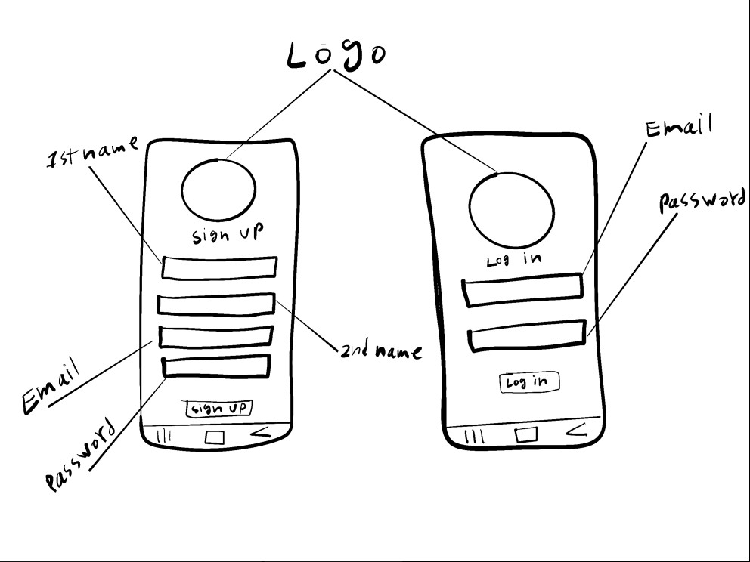

Payment
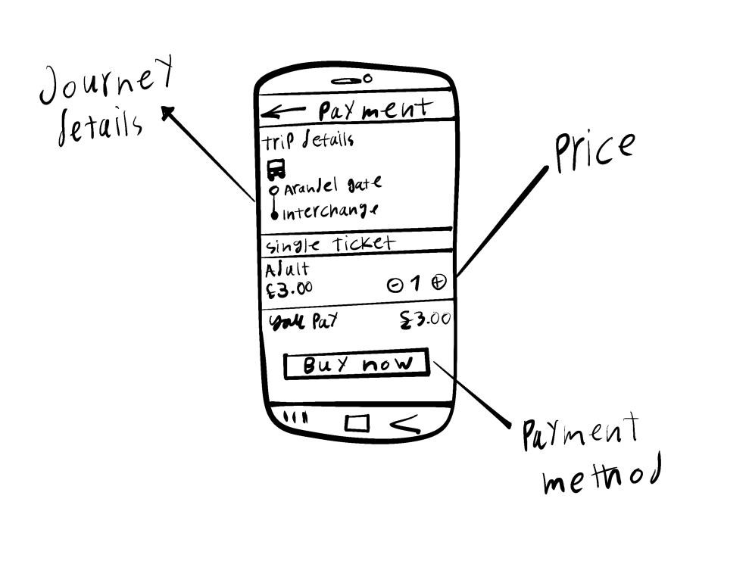

Tickets
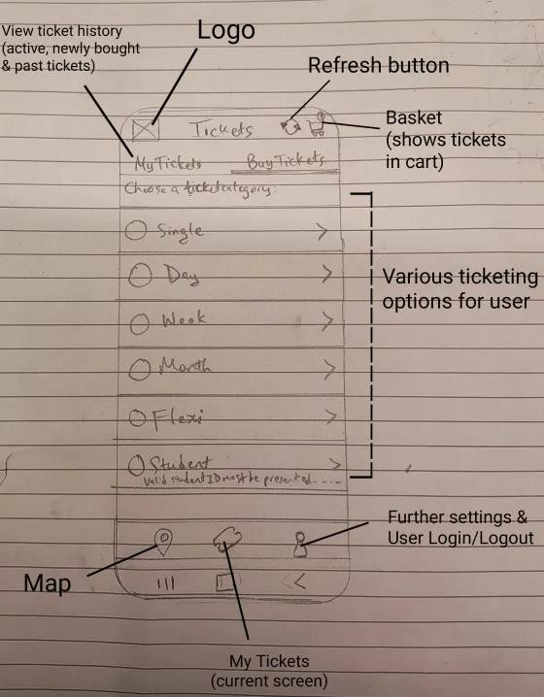

Settings
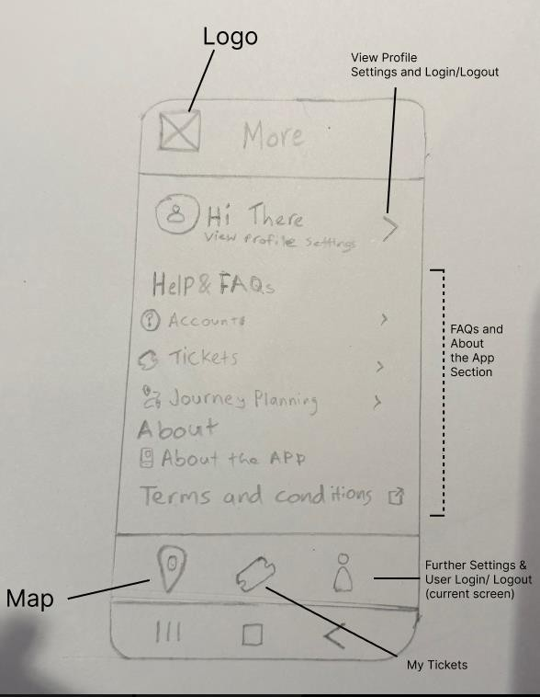

Map (Plan Journey/View Bus Stops)
